ZINC OXIDE EUGENOL IMPRESSION PASTE - A Review
Saranya ¹, Sanjna Nayar² , R.Shakila³
- Tutor, Department of prosthodontics, Sree Balaji Dental college &Hospital, BIHER.
- Head of the Department, Department of prosthodontics, Sree Balaji Dental college & Hospital, BIHER.
- CRI, Department of Prosthodontics, Sree Balaji Dental college & Hospital, BIHER.
RUNNING TITLE -ZINC OXIDE EUGENOL IMPRESSION PASTE
TYPE OF ARTICLE – REVIEW ARTICLE
CORRESPONDING AUTHOR:
Dr. Saranya,
Tutor,
Department of Prosthodontics,
ADDRESS:
Sree Balaji Dental College & Hospital,
Velachery main road,
Narayanapuram,
Pallikaranai,
Chennai – 100
EMAIL: sarani1980@gmail.com
Phone No: 9940069903
Source of funding – Nil
Conflict of Interest - Nil

ZINC OXIDE EUGENOL IMPRESSION PASTE
Saranya¹ , Sanjna Nayar² , R.Shakila³ ¹Tutor ,² Head of the department , ³CRI Department of prosthodontics,Sree Balaji dental college & hospital.
ABSTRACT
Impression making is one of the most important steps in prosthodontic rehabilitation of edentulous patients. Zinc oxide eugenol(ZOE) impression paste is most commonly used material for final impression. It is created by the combination of zinc oxide and eugenol contained in oil of cloves. Acid-base reaction takes place within the mixture to form zinc eugenolate chelate. The reaction is catalysed by water and is accelerated by the presence of metal salts.

INTRODUCTION
The zinc oxide eugenol impression pastes have been available to the profession since 1930’ s and have become increasingly popular in impression procedures in denture prosthesis^{[1]}. ADA specification no is 16. Zinc oxide eugenol (ZOE) impression paste is the most commonly used material for final impression making for edentulous jaws and rebasing of the complete denture^{[2]}.(fig.2) Due to its cost effectiveness and ease of manipulation, while providing the advantage of ability to record fine minute tissue details.

COMPOSTION
Base paste Accelerator paste
Zinc oxide-87% Eugenol-12%
Vegetable oil or gum or rosin-50%
Mineral oil-13% Filler(silica)-20%
Lanolin-3%
Resinous balsam-10% Accelerator solution (calcium chloride)
ZOE impression paste are available in two tubes.(fig.1) One base paste contains zinc oxide and vegetable or mineral oil, the other accelerator paste contains eugenol and rosin.
The vegetable or mineral oil acts as a plasticizer and aids in offsetting the action of the eugenol as an irritant.
Oil of cloves which contains 70 to 85% eugenol, is sometimes used in preference to eugenol because it reduces the burning sensation for patients when it contacts the soft tissues. The addition of rosin to the paste in the second tube facilitates the speed of the reaction and make the product more homogenous and smoother.
Balsam and balsam of peru are often used to increase flow and improve mixing properties. If the mixed paste is too thin or lacks body before it sets, a filler ( such as wax ) or an inert powder (such as kaolin, talc, or diatomaceous earth ) may be added to one or both of the original pastes.
SETTING REACTION
Zinc oxide reacts with water to form zinc hydroxide. The first reaction undergoes hydrolysis indicating, that water is essential to the reaction. Dehydrated zinc oxide will not react with dehydrated eugenol.
Water is one of the by-products of the reaction (auto catalytic). Zinc hydroxide that reacts with eugenol to form zinc eugenolate.
The setting reaction is a typical acid-base reaction and forms a chelate.
Zno+ _{H2O} Zn (OH)₂
Zn (OH)₂ +2HE ZnE₂ +2H₂O

SETTING TIME
Setting time is important, since there must be sufficient time for mixing, filling the tray, and seating the tray. Two setting times, initial and final, are recognized by the American dental association no. 16 for dental impression pastes. Also two types of paste are designated –Type I (hard) and Type II (soft). The difference between the two types is related to their hardness after setting.
INITIAL SETTING FINAL SETTING
TYPE I (Hard) 3-6 minutes 10 minutes
TYPE II (Soft) 3-6 minutes 15 minutes
Initial setting time represents the time at which the paste begins to set and can no longer be manipulated.^{[3]}
Final setting time is the time, from the start of mixing until the vicat needle either does not penetrate the surface of the set paste perceptibly or penetrate the mass in a minimum amount.^{[3]}

PROPERTIES
Flow- flow is the property of a material to change its shape under the influence of external load or under its own weight^{[4]}. Thin consistency paste will not compress the tissues and records the impression of the tissues which are at rest, such as impression known as mucostatic impression. Accordingly, denture made on such an impression will function better when the tissue are at rest, Such homogenous thin consistency paste flow uniformly and will not displace the tissues. Thick consistency pastes will show less viscous and set fast.
Dimensional stability- The dimensional stability decreased with increase in time and is influenced by both material factor and time factor^{[5]}. The dimensional stability of ZOE impression paste is quite satisfactory. A negligible shrinkage (less than 0.1%) may occur during hardening. No significant dimensional change subsequent to hardening should occur with high quality commercial products. The impressions can be preserved indefinitely without the change in shape that can result from relaxation or other causes of warping.
Strength- set paste has adequate rigidity and strength to resist deformation during removal.
USES
Cementing and insulating medium.
Surgical pack in periodontal surgical procedures.
Bite registration pastes.
Temporary relining material for dentures.
Impression material for edentulous patients.
MERITS
It has enough working time.
It can be checked in mouth repeatedly without deforming.
It registers accurate surface details.
It is dimensionally stable.
Does not require separating media since it does not stick to cast material.
Minor defects can be corrected.
DEMERITS
Require special tray for impression making.
Sticky in nature and adheres to tissues.
Burning sensation of eugenol causes tissue irritation.
Highly inelastic in nature.
Balsam of peru is one of the common allergens causes inflammation and redness.
DISCUSSION
An ideal impression material for complete denture impression should have adequate flow and consistency so that records the tissue details properly without causing distortion of the tissues. Recording of accurate tissue details is one of the primary requisites of ideal impression materials. Today we have various newer material such as light body polyvinylsiloxane for accurate impression. However, their cost is still a major concern, especially in teaching institutes and even in practice, this makes as most widely used impression material.
CONCLUSION
Zinc oxide eugenol impression paste is a mucostatic material. It is a traditional material used to record final impression, wash impression and pick up impression. Also used as a surgical pack, for bite registration and also used in interocclusal records. On comparison with light body polyvinylsiloxane, it has been found to have slightly lower accuracy. ZOE is economical and hence it is more widely used and preferred material.
REFERENCES
- G. E. MYERS and F. A. PEYTON, university of Michigan, school of dentistry, Ann Arbor, Michigan, physical properties of the zinc oxide-eugenol impression pastes, received for publication January 28, 1960; revised by authors July 27,1960. (39-48)
- Sareh habibzadeh, shima safaeian , marjan behruzibakhsh , parisa kaviyani, mohamadjavad kharazifard , effects of storage time and temperature on dimentional stability of impressions made with zinc oxide zinc oxide impression paste , June 2016;vol.13,no.3(201-206)
- Chung suck lee,D.D.S. , zinc oxide eugenol impression pastes-a study of an impression material(57-63)
- Anuj harish chandak, saee p. Deshmukh,usha M. Radke, Rajilakshmi s.banerjee, Tushar k. Mowade, Akhil rathi ,An in vitro study to evaluate and compare the flow property of different commercially available zinc oxide eugenol impression materials,July 2,2018 (s137-s141)
- Sampath Kumar Tejo, Anil G Kumar,Vivekanand S Kattimani, priti D Desai , Sandeep nalla and Krishna chaitanya K ,a comparative evaluation of dimentional stability of three types of interocclusal recording materials-an in-vitro multi-centre study,published:5 0ctober 2012.

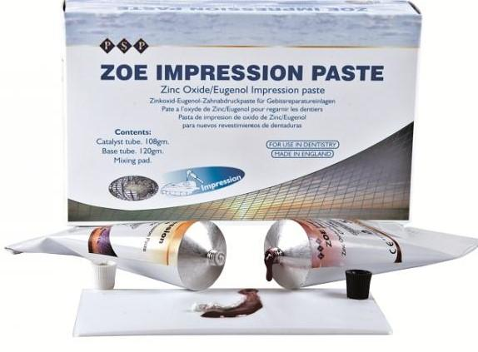
Fig .1

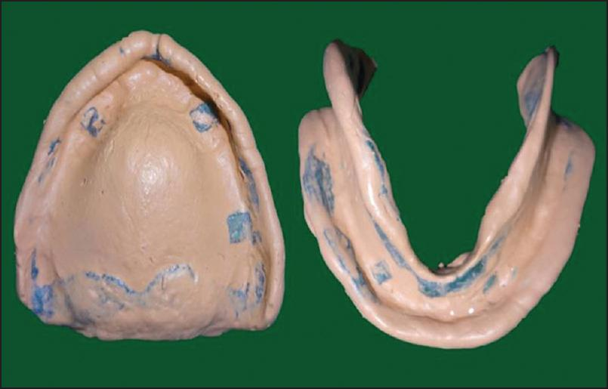
Fig .2

