USE OF IMPLANTS TO IMPROVE UNFAVOURABLE REMOVABLE PARTIAL DENTURE DESIGN – A SYSTEMATIC REVIEW
Sanjna Nayar¹, Manochitra VS.²

- Head of the Department, Department of Prosthodontics, Sree Balaji Dental College & Hospital, BIHER.
- CRI, Sree Balaji Dental College & Hospital, BIHER.

RUNNING TITLE: USE OF IMPLANTS TO IMPROVE UNFAVOURABLE REMOVABLE PARTIAL DENTURE DESIGN
TYPE OF ARTICLE: REVIEW ARTICLE

CORRESPONDING AUTHOR:
Dr. Sanjna Nayar, MDS, PhD
Head of the Department
Department of Prosthodontics.
Address:
Sree Balaji Dental College & Hospital, BIHER,
Velachery Main Road,
Narayanapuram,
Pallikaranai,
Chennai -100.
EMAIL: nayarsanjna@gmail.com
Phone No: 9840435302
SOURCE OF FUNDING: Nil
CONFLICT OF INTEREST: Nil

USE OF IMPLANTS TO IMPROVE UNFAVOURABLE REMOVABLE PARTIAL DENTURE DESIGN

Sanjna Nayar¹, Manochitra VS.²
- Head of the Department, Department of Prosthodontics, Sree Balaji Dental College & Hospital, BIHER.
- CRI, Sree Balaji Dental College & Hospital, BIHER.

ABSTRACT
Conventional removable partial dentures in Kennedy class I patients allows continuous bone resorption, dislodgment of the prosthesis during the mastication caused by the resilience of the mucosa, rotation of the prosthesis causing discomfort to the patient. Thus, the use of distal implants may become an attractive method of treatment for these patients. This will improve function and biomechanics, at a comparatively reduced cost.
INTRODUCTION
There are many ways to treat partially edentulous patients. If tooth-supported fixed partial dentures cannot be constructed due to an unfavorable number and/or distribution of teeth, removable partial dentures (RPDs) are typically prescribed. (FIG. 1)
A removable partial denture is generally indicated for edentulous spaces greater than two posterior teeth, anterior spaces greater than four incisors, or spaces that include a canine and two other continuous teeth.
An edentulous space with no distal abutment will usually require a removable partial denture
The use of RPDs has been associated with poor patient acceptance due to lack of stability in part due to the rotation of the prosthesis seated on top of soft tissue, compromised function caused by discomfort upon loading, and poor esthetics (cases in which the retentive clasp arms are visible). To alleviate these drawbacks, the use of a small number of dental implants in conjunction with a removable partial denture can be an effective prosthodontic alternative. In the last few decades, dental implants have become a valuable option for prosthodontic rehabilitation. ^{(1,2, 3)} (FIG. 2)
IMPLANTS AS DISTAL ABUTMENTS
The most common failure of the RPD is predominantly due to fatigue of the clasp unit and incorrect casting or poor design of the framework. The above issues associated with Kennedy class I RPDs have led to the use of posterior implants to resolve the biological issue. Placing two implant abutments distally in the mandible has been recommended to transform a Kennedy class I RPD into a tooth and implant assisted removable partial denture (IARPD) (or pseudo-Kennedy class III). (FIG. 3,4)
Implants can be combined with an RPD in a number of ways. They can be used with a healing abutment to provide support to prostheses. A precision attachment can also be fitted if extra retention is needed to support the rest of the retentive elements of the RPD. Alternatively, implants can be used as abutments for a fixed prosthesis, either by supporting an RPD or as abutments to a telescopic crown RPD. The rationale behind the use of dental implants in conjunction with RPDs is to improve denture design by optimizing the distribution of abutments (teeth and implants). Since there is no rigid connection between implants and natural teeth, complications—such as intrusion of teeth and peri-implant bone loss, which often occur when connecting teeth with implants—are avoided
RPDs associated with implants can be considered as an intermediate prosthodontic solution between a conventional RPD and a fixed implant-supported restoration. They can be modified towards either of these 2 directions: they can be converted to a conventional RPD in case of failure of the implants, or they can be replaced by an implant-supported fixed partial denture by placing additional implants. It is therefore a highly versatile type of restoration that does not alter the patient’s dental condition in an irreversible manner.
The posterior region of the oral cavity is usually the first area to lose teeth, and results in a multi-factorial process of bone loss, by alveolar bone resorption. This process occurs throughout life and ultimately leads to reduced bone depth, compromising oral rehabilitation. This is particularly clinically relevant in the posterior area of both the maxillary and mandibular arches, due to the presence of important anatomical structures, as well as bone quantity and quality, which represent the main limiting factors for implant insertion.
Longitudinal studies have demonstrated that implant prostheses represent a predictable and successful restorative solution for these cases. However, studies are still needed to provide more evidence on certain issues, such as design guidelines, long-term survival of implants associated with RPDs, and their effect on patients’ quality of life. These prosthodontic modifications cannot always be realized due to several factors, such as a patient’s compromised general health, anatomical makeup, financial limitations, and/or personal preferences.
Many partially edentulous individuals do not fully understand the benefit of the implant use and may hesitate to pay the extra cost. For these patients, a conventional RPD can be manufactured, and if the patient experiences retention or stability problems after the delivery of the restoration, implants can be placed, and the existing dentures can be adapted to them. ^{(3,4,5,6)} (FIG. 5, 6)
IMPLANT ASSISTED REMOVABLE PARTIAL DENTURE (IARPD)
- Implants in conjunction with a Kennedy class I RPD were used for the first time in the early 1970s, and since then clinical trials have indicated good implant survival rates
- Mijiritsky et al. reported IARPD wearers had improved chewing ability and higher patient satisfaction. It is also well accepted that the use of implants to stabilize and support mandibular prostheses can increase maximum muscular function.
- Grossmann et al. explained how important it is to consider the loading situation in the mandible because of the significant displacement of the denture base if it is not supported by the major connector.
- Carpenter reported that it would be best to construct a new RPD, indicating that this could avoid the major complication for IARPDs, which is the fracture of the acrylic around the implant attachment housing. Carpenter recommended the IARPD should be well reinforced, with metal around the location of the implant attachments.
- Kaufmann et al. found that technical complications were a regular occurrence. In the first year there was a very high rate of technical complications, mostly related to the anchorage system (matrices) of root copings and implants. T he cause of the complications can be linked to the additional forces placed on the prostheses and the altered support structure that needs to resist these forces.
- Verri et al. used finite element analysis to measure the influence of the occlusal forces on IARPDs. They verified that there was no reduction in the tension forces on the abutment teeth, but there was a reduction in the support required from the posterior half of the residual ridge. Bilateral balanced occlusion is suggested as an option for distal extension IARPD, to evenly distribute forces across the prosthesis; however, such an occlusal design is not easily achievable especially when the opposite arch is fully dentate.
- Ohkubo et al. conducted a single blind randomized crossover study of 5 partially edentulous patients (Kennedy class I). The study showed that the masticatory force and contact areas were greater and more distally located following placement of an IARPD.
- Del’ArcoPignatta Cunha et al.’s finite element analysis study of the influence of the location of the implants in association with an IARPD found that maximum stress was located around the implant in all situations. T his study investigates how unilateral and bilateral occlusal loads are transferred to the IARPD. The hypothesis is that the location of the occlusal load will not alter the way the strain is transferred to the IARPD. There are currently no studies comparing the effects of bilateral versus unilateral loading on Kennedy class I IARPD.^{(6, 7, 8)}
ADVANTAGES
- Enhanced retention, support and stability
- Improved aesthetics with elimination of some retentive clasps
- Preservation of remaining residual ridge by better distribution of forces and elimination of damaging leverage to natural abutment teeth
- Improved comfort and confidence
- Psychological advantage to patient of preserving compromised natural teeth that are not suitable to use as abutments to support an RPD
- Increase in masticatory efficiency
- A futuristic treatment plan where implant placement may be staged and this prosthesis can be used as an interim option
- Implants were used as either vertical stops to enhance prosthetic support or with resilient retentive elements
- A common problem associated with the mandibular bilateral distal extension RPD opposing a maxillary complete denture is known as the Combination (or Kelly) Syndrome, which is a result of the lack of a stable occlusion. A posterior implant, offering distal support to the RPD base, might prevent the development of Combination Syndrome manifestations.
- RPDs can also be used to handle implant failures of fixed restoration treatment plans. When the number of remaining implants that are originally placed in order to support a fixed prosthesis does not suffice to proceed with the initial treatment plan, and if additional surgery for the replacement of lost implants is not advisable, an RPD associated with the remaining implants can be an effective alternative. RPDs can be used as interim restorations for staged implant placement; they are a cost-effective prosthodontic solution
- The implants acting as posterior stops that inhibit the movement of the denture base toward the soft tissue under loading and thus contribute to a more stable occlusion
- The implant support prevented the displacement of the distal extension RPD and decreased the pressure on soft tissues, which would theoretically improve the patient’s comfort.
- The authors concluded that a single implant placed underneath a distal extension RPD provides a stable occlusion, which might prevent bone remodeling in the tempero mandibular joint. Implants used in conjunction with RPDs can drastically improve a patient’s chewing ability
- Bone is preserved around the site of implant placement as a result of remodeling stimulation, and the residual ridge resorption is expected to be minimal, since the stress transmitted to the underlying bone from the denture base is partly absorbed by the implants. Thus the need for frequent relining of the denture is eliminated. ^{(8, 9,10)}
DISADVANTAGES
- Increased cost compared to conventional partial dentures
- The need to perform surgery in order to place implants, and a more complicated clinical and laboratory construction protocol when compared to conventional RPDs. ^{(9,10)}
COMPLICATIONS
Several studies have reported complications, such as screw loosening, framework fracture, loosening of healing caps, fracture of framework, and/or acrylic denture bases
Prosthetic complications tend to occur more frequently during the first year of prostheses’ function.
These complications tend to be readily alleviated by simple actions such as abutment screw tightening, replacement or polishing of the surface of the healing abutment, replacement of the resilient components of attachment systems, and/or matrix activation^{. (10)}
CONCLUSION
Patients with Kennedy class I mandibular implant assisted removable partial dentures will be more satisfied with distally placed implants compared to conventional mandibular removable partial dentures as there is improved stability, subjective chewing ability, esthetics, function and overall patient satisfaction with a high implant survival rate after a maximum of 16 years.
REFERENCES
- Eitan Mijiritsky, Zeev Ormianer, Avigdor Klinger, Ofer Mardinger, Use of Dental Implants to Improve Unfavorable Removable Partial Denture Design,Compendium/ Oct. 2005, Vol.26, No.10.
- Reza Shahmiri, John M. Aarts, Vincent Bennani, Michael V. Swain, Strain Distribution in a Kennedy Class I Implant Assisted Removable Partial Denture under Various Loading Conditions – Research Article, Hindiwi Publishing Corporation, International Journal of Dentistry,2013, Vol.11.
- Marcele Jardim Pimentel, Juan Pablo Arrellaga, Atais Bacchi, Altair A. Del Bel Cury, The Use of Implants to Improve Removable Partial Denture Function, J Indian Prosthodont Soc (December 2014) 14(Suppl. 1): S243-S247.
- Lalit kumar,Komal Sehgal, Removable Partial Denture supported by implants with prefabricated telescopic abutments- A case report, Journal of clinical and diagnostic research, June 2014, Vol-8, Issue-6, ZD04-ZD06.
- Eitan Mijiritsky,Sivan Karas, Removable partial denture design involving teeth and implants as an alternative to unsuccessful fixed implant therapy: A case report, Implant Dentistry, 2004, Vol-13, No-3,218-220.
- Daniel Wismeijer,Andrew Tawse-Smith,Alan GT Payne,Multicenter prospective evaluation of implant assisted mandibular bilateral distal extension removable partial dentures: Patient satisfaction, Clin.Oral Impl.Res. 2013, Vol.24, 20-27.
- Githanjali Manchikalapudi,Aditi Prasad, Laxman Rao Polasani, Attitude of partial denture wearers towards implant treatment and its association with oral hygiene status, age,gender and extent of edentulousness- A cross sectional study, International journal of applied dental sciences, 2017, Vol.3, Issue.4, 16-20.
- Charlotte Jensen, Henny JA Meijer, Gerry M Raghoebar,Wouter Kerdijik, Marco S Cune, Implant supported removable partial dentures in the mandible: A 3-16 year retrospective study, Journal of prosthodontic research,2017, Vol.61,98-105.
- Liran Levin, Dealing with dental implant failures, J Appl Oral Sci.2008, Vol.16,Issue 3, 171-175.
- Konstantinos Chatzivasileiou, Eleni Kotsiomitii, Ioannis Emmanouil, Dent, Implant assisted removable partial dentures as an alternative treatment for partial edentulism: a review of the literature, General Dentistry, Mar/Apr 2015.

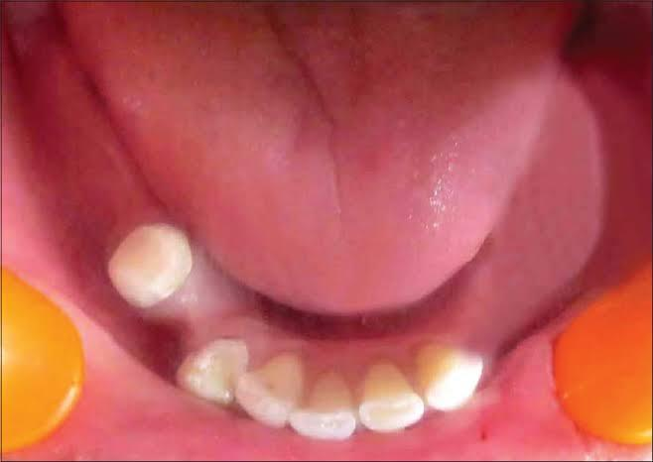
FIG. 1
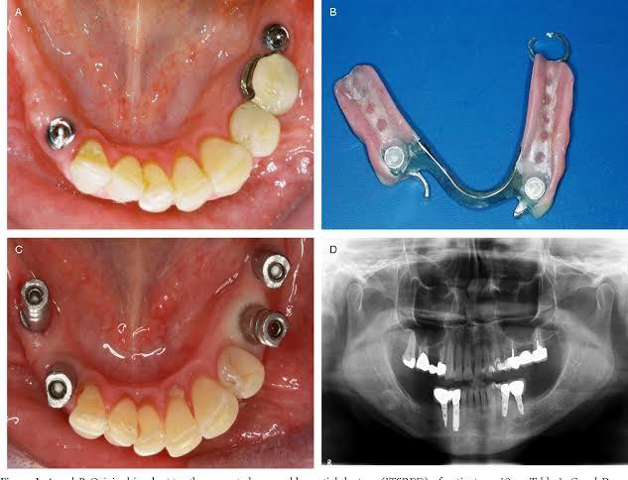
FIG. 2
FIG. 3

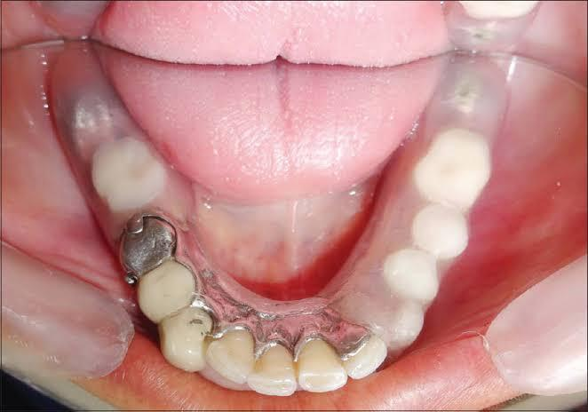
FIG. 4
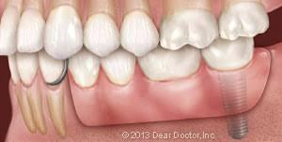
FIG. 5
FIG. 6

