LABORATORY STEPS FOR UNILATERAL PRECISION ATTACHMENT
PHOTO 1 & 2 : Armamentarium – Wax palette, Wax dropper, Wax coping on Prepared teeth, Rhein Attachments
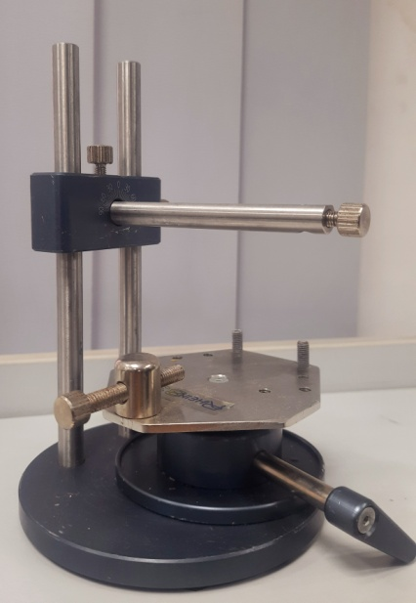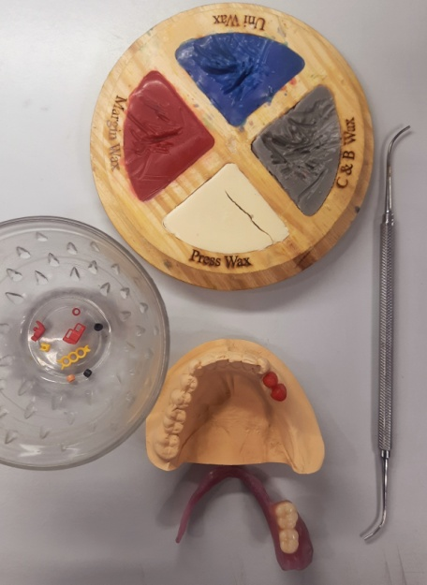
PHOTO 3 : Cast is adapted on a Parallelometer
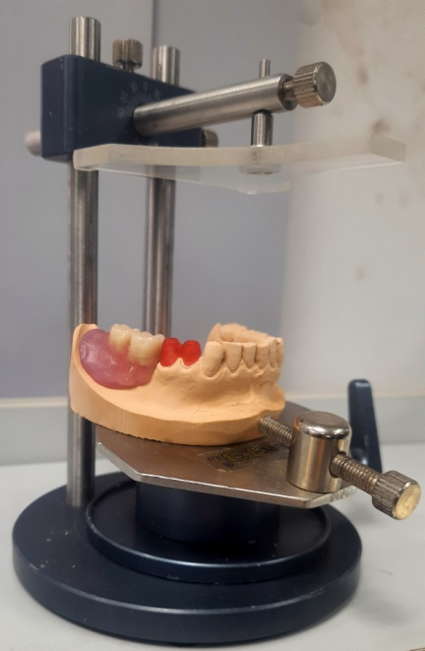
PHOTO 4 : Occlusal Plane is analysed
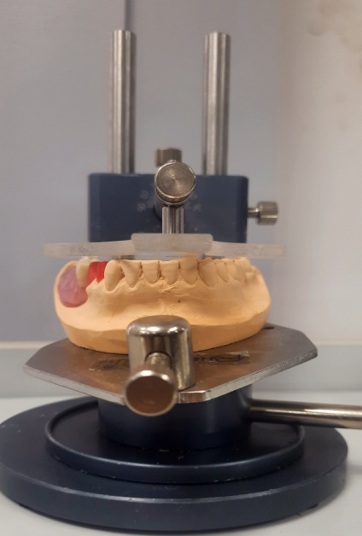
PHOTO 5 : “Primary Attachment “ is connected to the mandrel
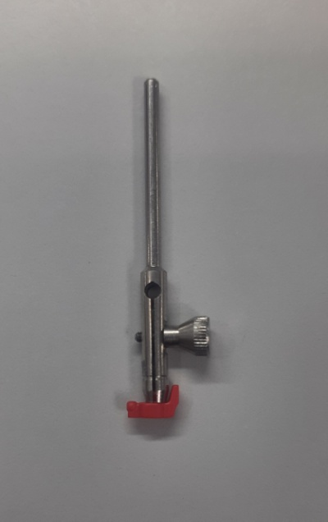
PHOTO 6 : “Primary Attachment” is attached to the distal surface of abutment wax coping using a pattern resin.
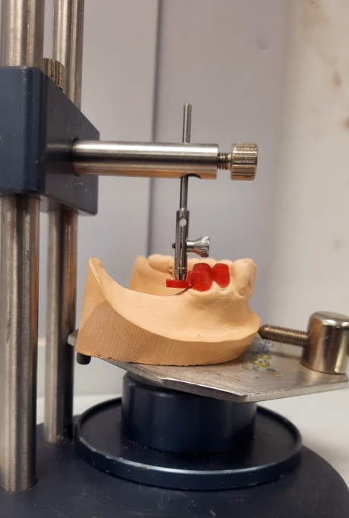
PHOTO 7 : “Primary Attachment” is separated from mandrel
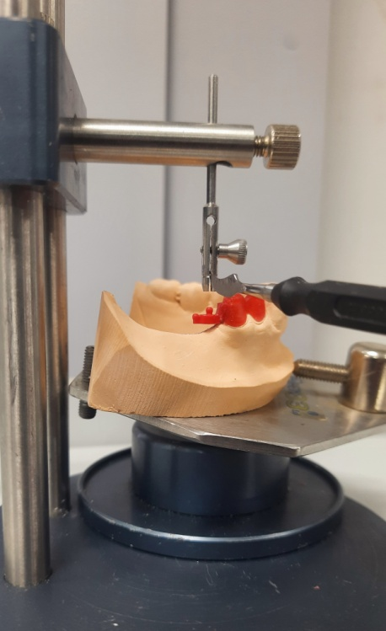
PHOTO 8 : Seperating Medium is applied
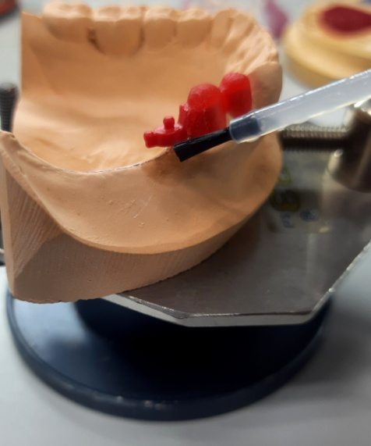
PHOTO 9 : The Primary Attachment is stabilized using a Pattern Wax
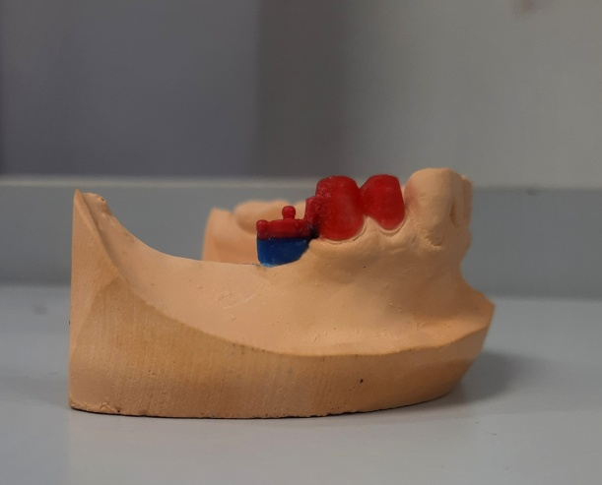

PHOTO 10 : Wax Spacer with Tissue stop is adapted over the ridge
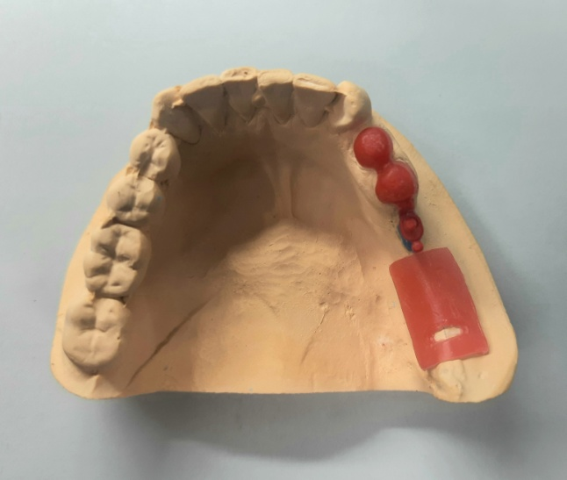
PHOTO 11 : “Secondary Attachment with connector” is placed onto the Primary Attachment. Tissue stop is filled with pattern resin and connector is attached to it.
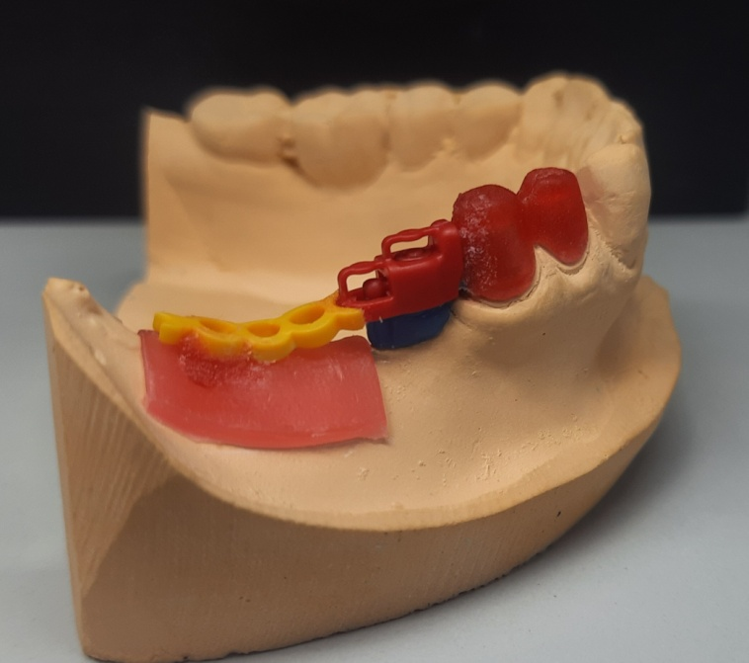
PHOTO 12 : Sprue is attached and prosthesis is proceeded for casting.
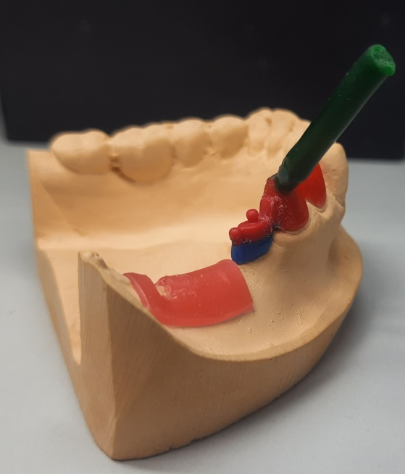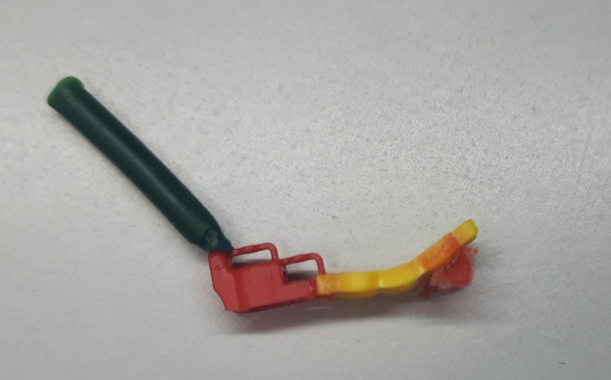
PHOTO 13 : Prosthesis is casted( fig 1). Resilence( elastic ) is fixed inside secondary attachment.(fig 2)
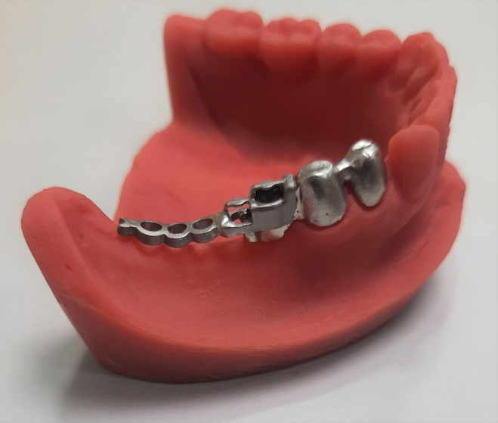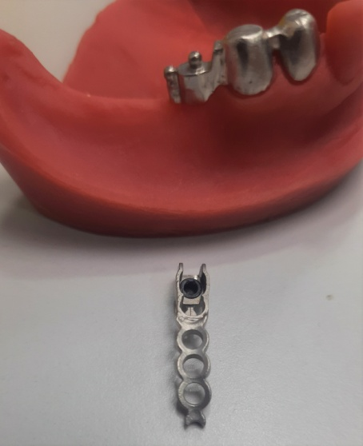
PHOTO 14 : Ceramic layering is done on abutment teeth
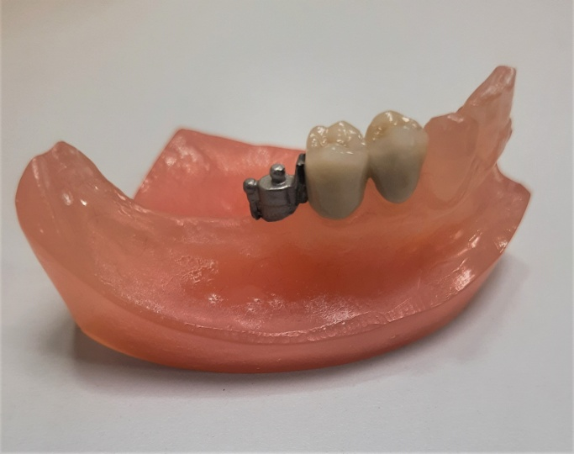
PHOTO 15 : Acrylisation of secondary attachment along with teeth is done.
