MAXILLARY PALATAL PLATE OBTURATOR
Patient Name: Mr. Shivajirao Pawar
OPD number: 39565
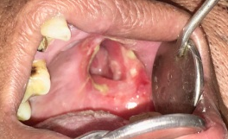
Pre-operative

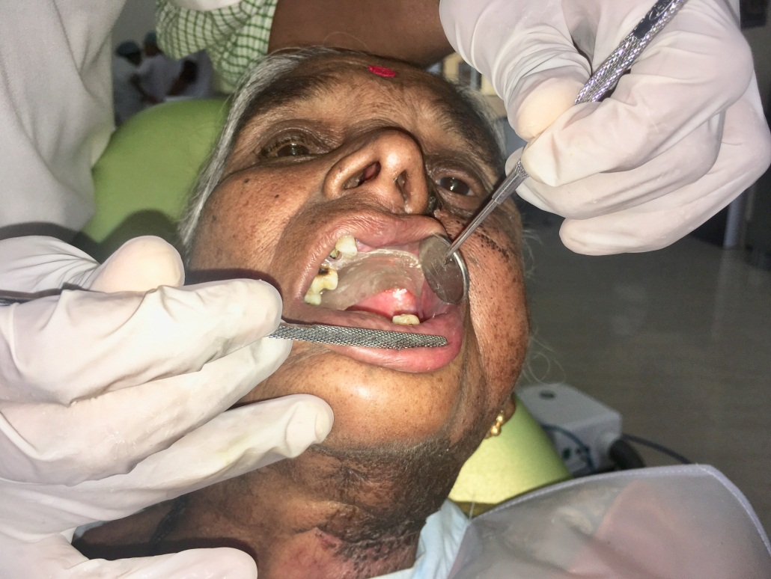
Post-operative

IMPLANT RETAINED OVER-DENTURE
Patient Name: Mr. Somnath Khandagale
0PD number: 38355
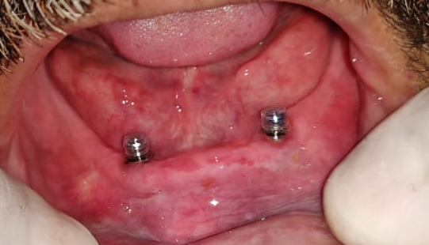

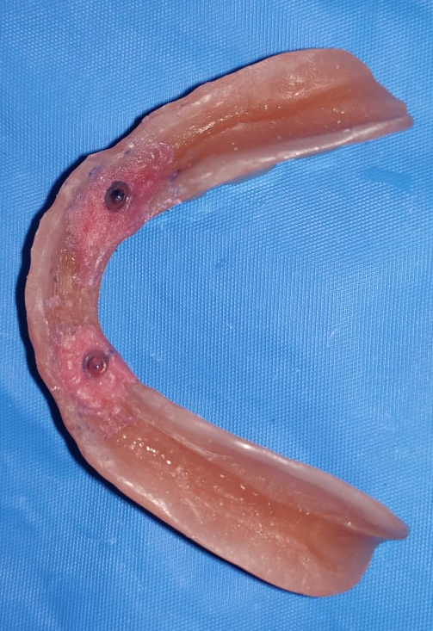
2 Implants with Stud Attachment(PATRIX)

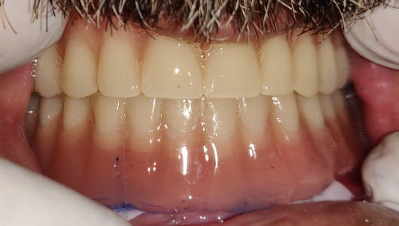
MATRIX on Intaglio surface

Post-operative

FULL MOUTH REHABILITATION
Patient Name: Mrs. Indira Tanna
OPD Number: 36868
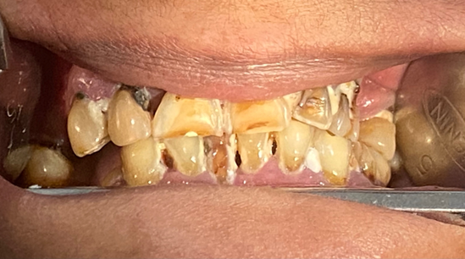
Pre-Operative
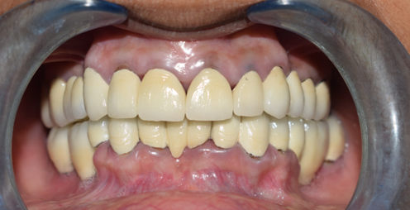
Post-Operative

FULL MOUTH REHABILITATION
Patient Name: Mr. Arun Mhaske
OPD number: 15805

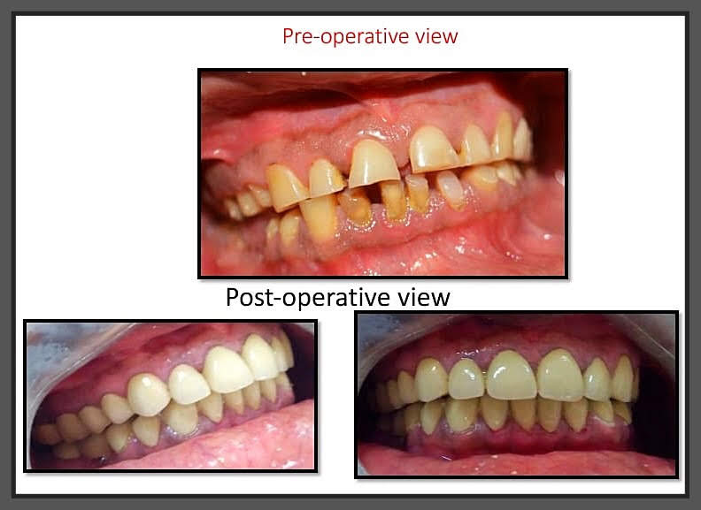

Pre-operative view

Postoperative view

SOCKET SHIELDING TECHNIQUE – 1
Patient Name: Mrs. Renu Tiwari
OPD number: 118270
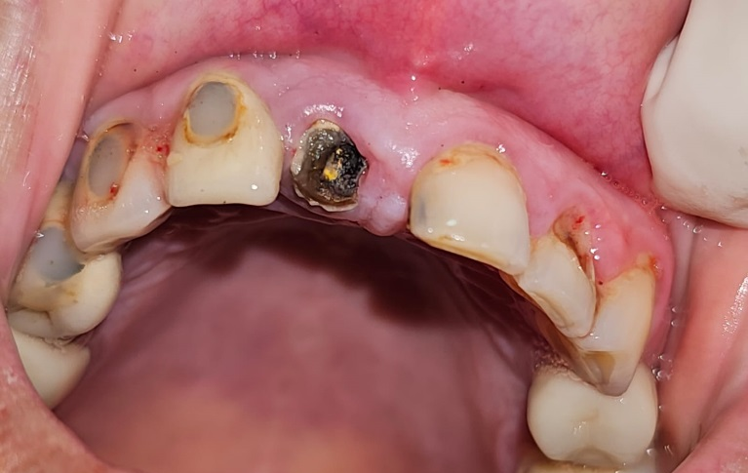
Pre-Operative
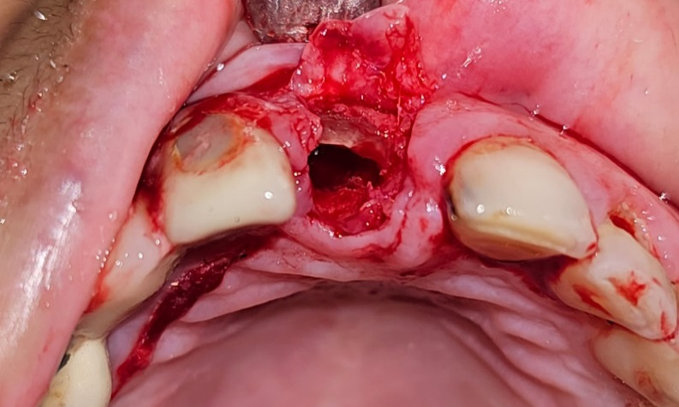
Buccal root section intact
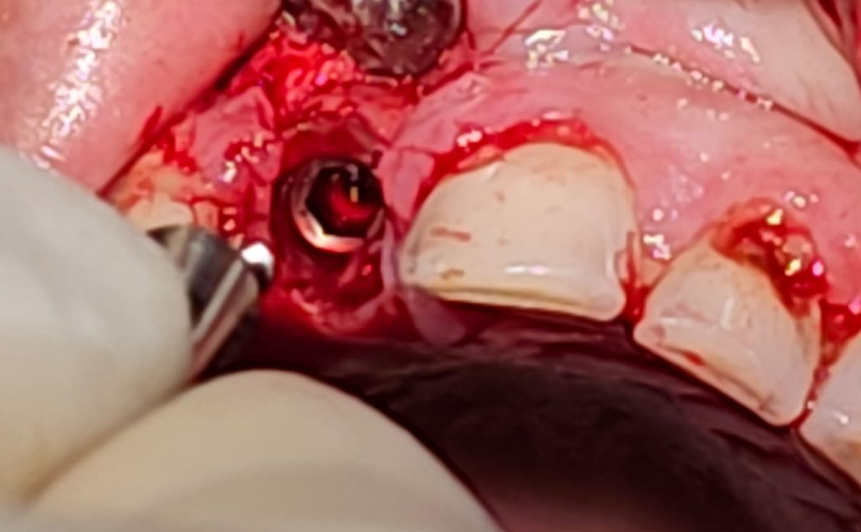
Post-Operative
OCULAR PROSTHESIS
Patient Name: Mr. Chandan
OPD number: 32875

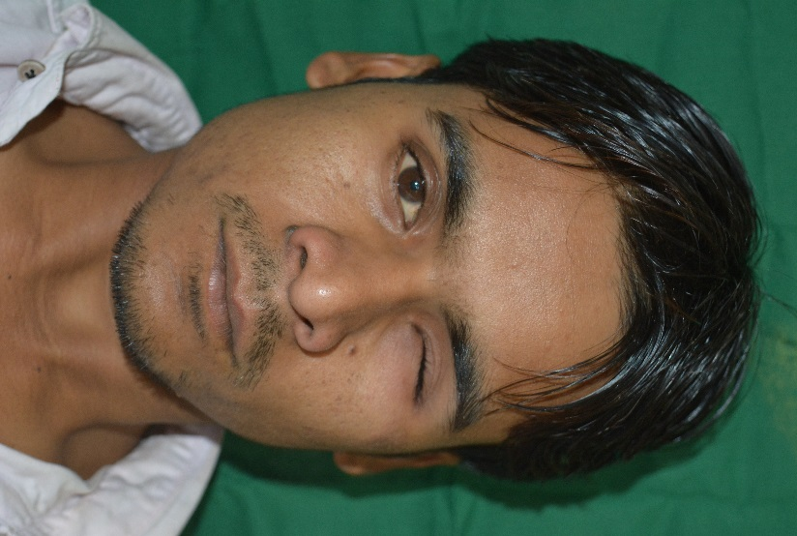

Pre-Operative
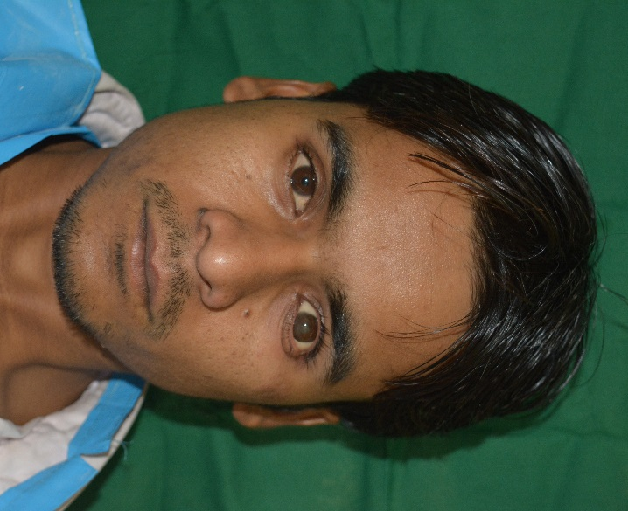

Post-Operative

SOCKET SHIELDING TECHNIQUE – 2
Patient Name: Mrs. Namita Wambhure
OPD number: 110311
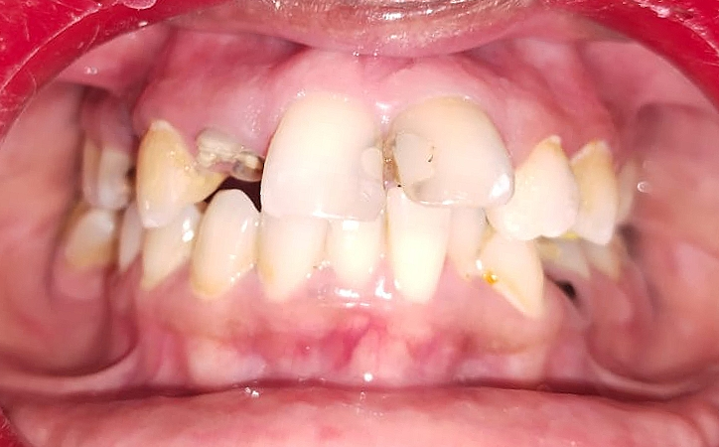
Pre-Operative
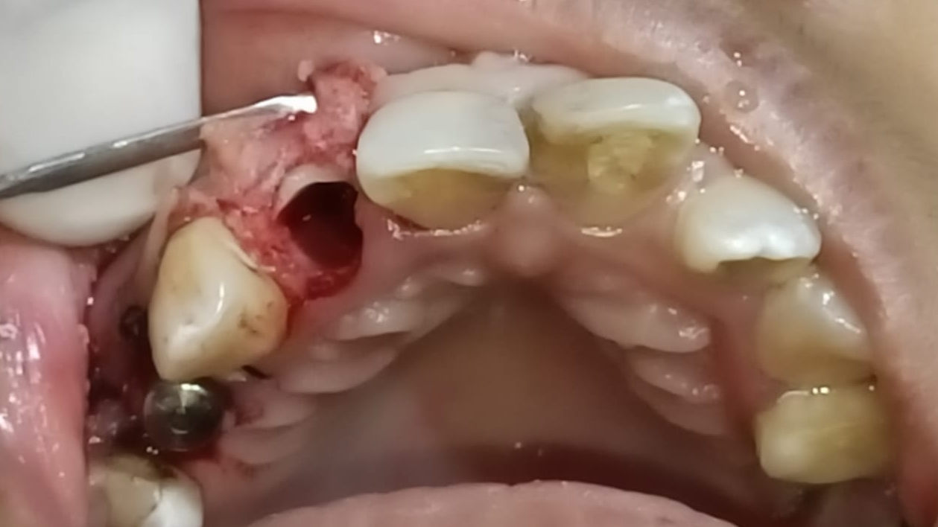
Buccal root section intact
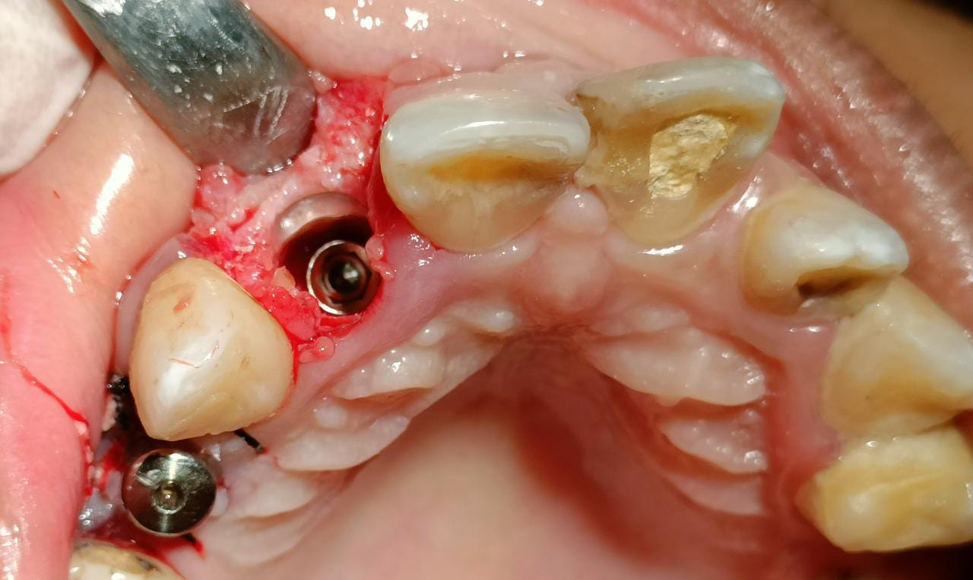
Post-Operative
FEEDER PLATE- 1
Patient Name: Baby Bhagat
OPD number: 18582
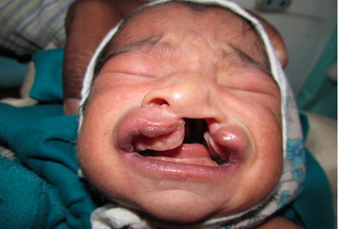
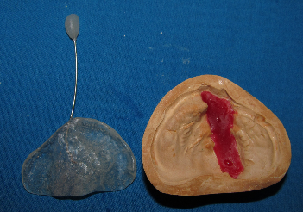
Pre-Operative

Prosthesis
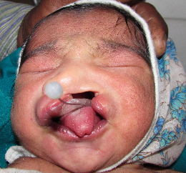
Post-Operative
FEEDER PLATE- 2
Patients Name: Baby Gondawane
OPD number: 26922
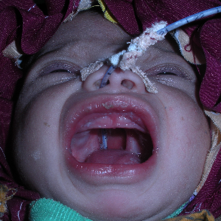
Pre-Operative
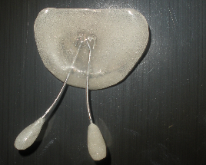
Prosthesis
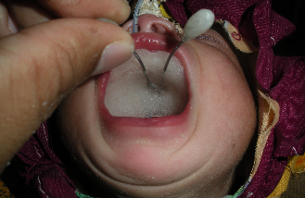
Post-Operative
GUIDE PLATE
Patient Name: Mr. Ashish Gadhewal
OPD Number: 29280

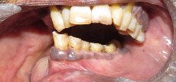
Pre-Operative
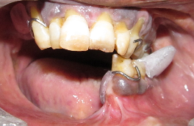
Post-Operative

DEFINITIVE OBTURATOR
Patient Name: Mr. Pravin Shinde
OPD number: 32305

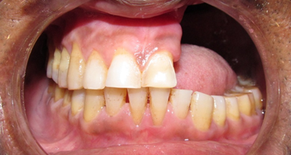
Pre-Operative

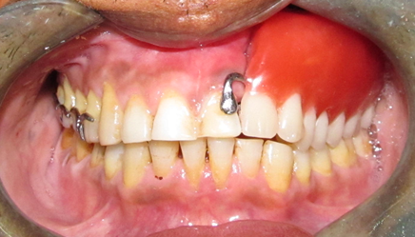
Post-Operative

POST AND CORE
Patient Name: Ms. Preeti Gaikwad
OPD number: 26922
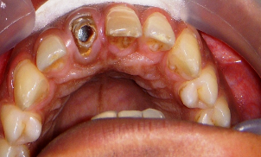
Pre-Operative
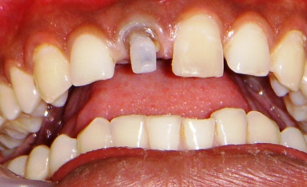
Core Build-up
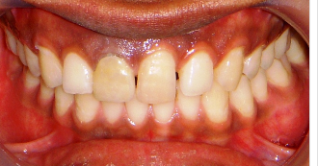
Post-Operative
PORCELAIN VENEERS
Patient Name: Mrs. Ashwita Mehta
OPD number: 36093

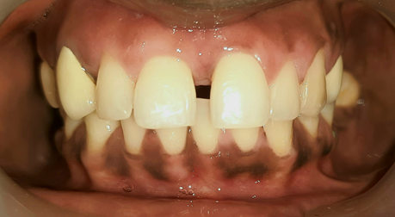
Pre-Operative

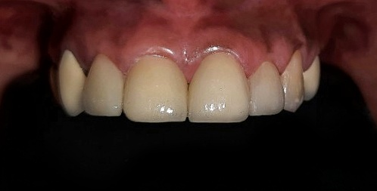

Post-Operative

FULL MOUTH REHABILITATION WITH DENTAL IMPLANTS
Patient Name: Mrs. Aishwarya Sawant
OPD number: 43783
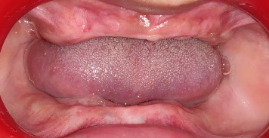

Pre-Operative

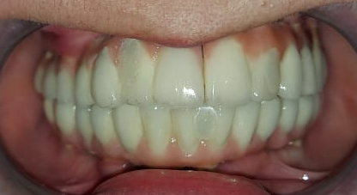
Post-Operative

MANDIBULAR IMPLANT SUPPORTED FIXED PROSTHESIS
Patient Name: Mr. Kalyan Chepate
OPD Number: 72747
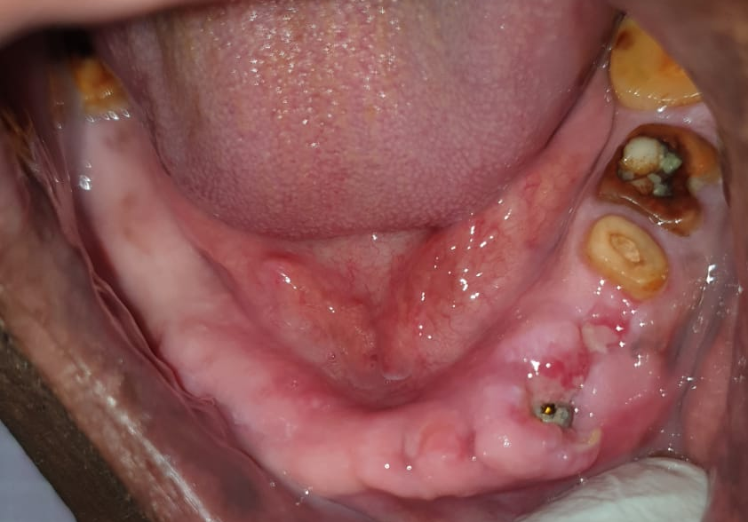

Pre-Operative

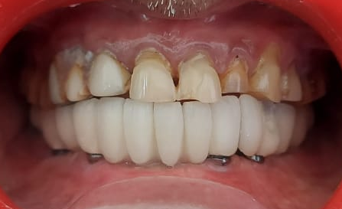
Post-Operative

INTRAORAL-EXTRAORAL COMBINATION PROSTHESIS
Patient Name: Mr. Suyog Dongre
OPD number: 117941
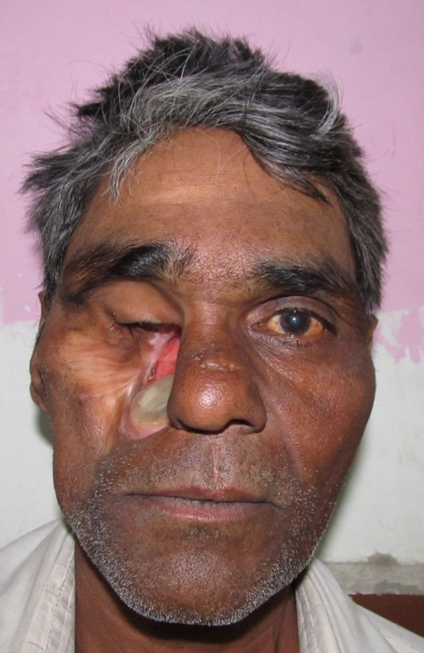
Pre-Operative
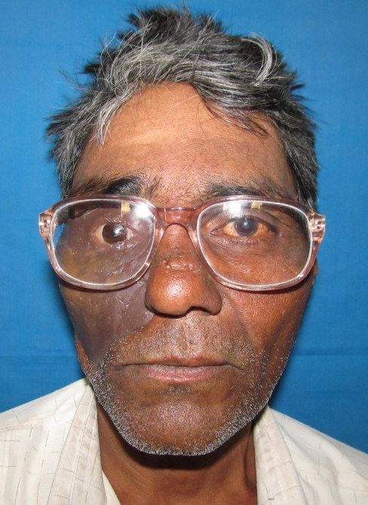
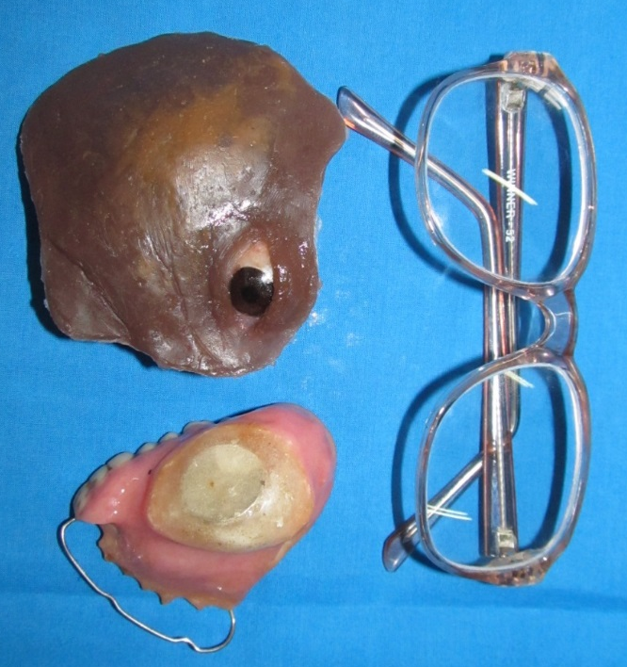

Prosthesis Post-Operative

IMPLANT RETAINED OVER-DENTURE
Patient Name: Mrs. Pushpa Pandey
0PD number: 29730
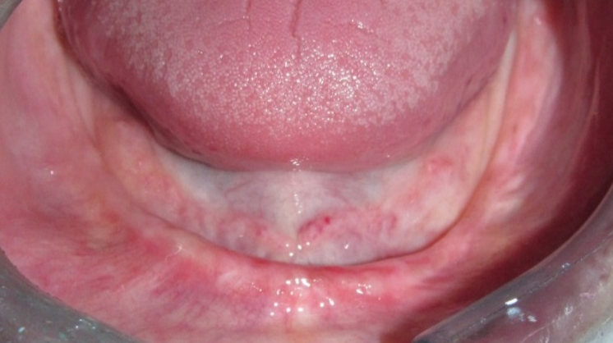
Pre-Operative
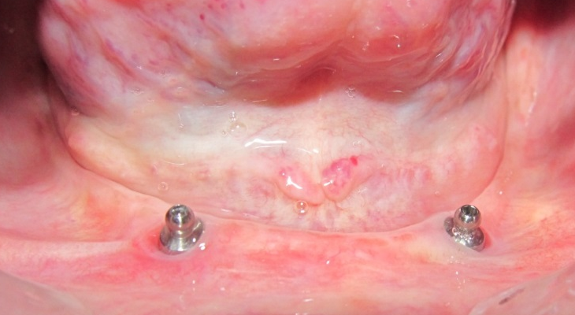
2 Implants with Stud Attachment(PATRIX)
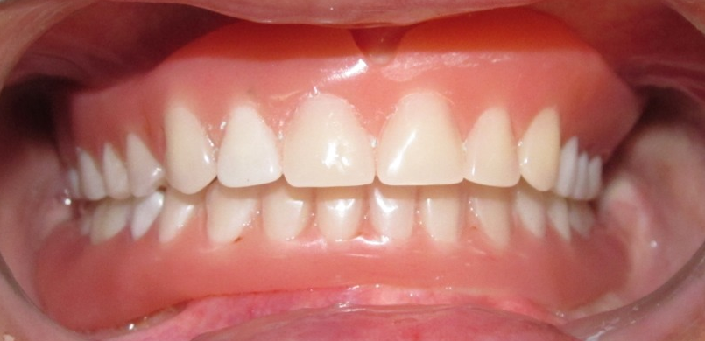
Post-Operative

ALL-ON-4 with MANDIBULAR ARCH
Patient Name: Mrs. Neha Agarwal
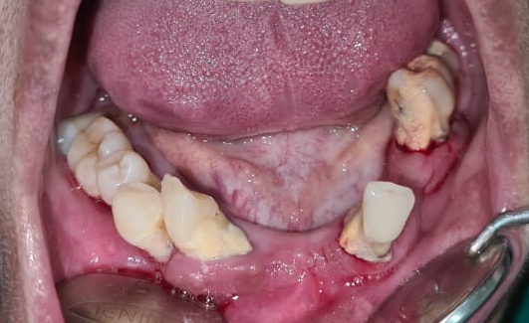
OPD number: 96894
Pre-Operative
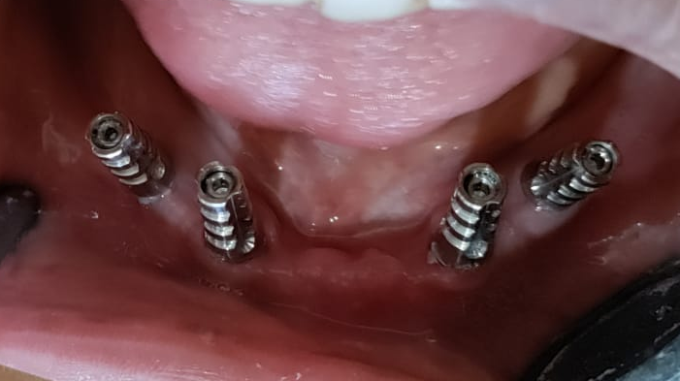

Implants placed using ALL-ON-4 technique
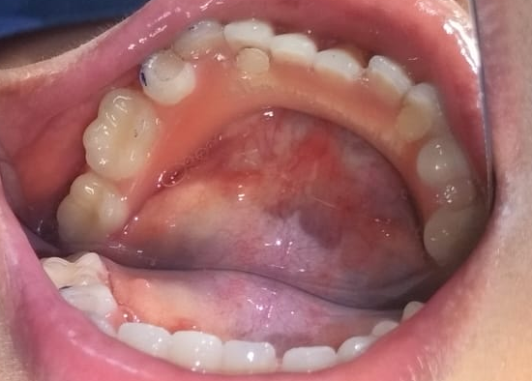
Post Operative
FULL MOUTH REHABILITATION
Patient Name: Mr. Bharat Paal
OPD Number: 128065

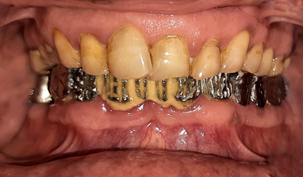
Pre-Operative

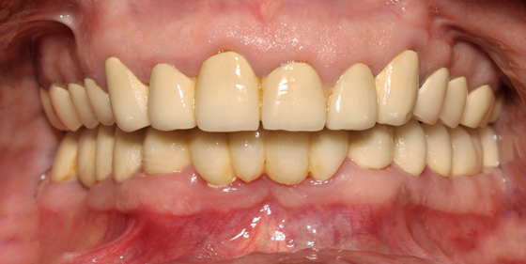
Post-Operative

MANDIBULAR OVER-DENTURE
Patient Name: Mr. Raja Singh
OPD number: 117941

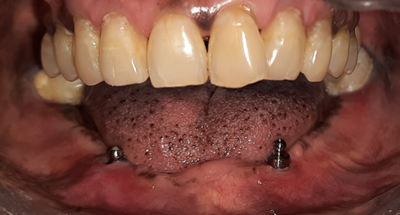
2 implants placed in canine region. Stud attachments (PATRIX) attached.
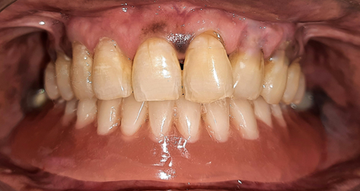
Post Operative

